The Messengers
Overview (Games Workshop Baltimore GT 2000)

Electromagnetic interference is preventing your army from communicating with its superiors. Messengers have been sent to inform the superior officers that contact has been made and reinforcements should be sent.
Scenario Special Rules
Before the battle begins, both sides must nominate three models to be their messengers. These models must be Troop selections from three different units. The messengers are removed from their units and are treated as independent characters for the rest of the game. Note that the following profile is in effect for all messenger models. M-8, WS-4, BS-4, S-4, T-4, W-2, I-4, A-2, LD-9, and Save 4+, Invulnerable. Messengers may always ignore terrain penalties. In addition, they will automatically pass any Morale checks they have to take, even if faced with a situation that would normally cause them to automatically fail (that’s why they’ve been chosen to be messengers).
Your messengers must try to escape the battlefield via any table edge but your own (that’s where your fourth messenger went!) Each messenger is duty bound to go in a different direction, so each one must leave the table via a different table edge.
Escaping on the side edges: The messengers may escape on the side edges in the 12” furthest away from your deployment zone (see the set up map).
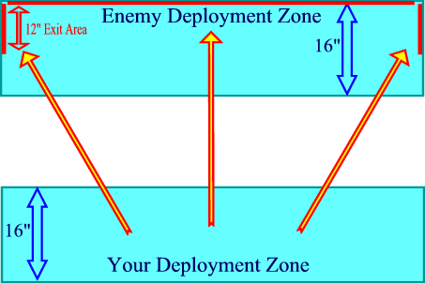
Set-Up
1 | Each player rolls a D6, the player with the highest score choosing a long table edge for deployment.
2 | Both players roll a D6, the player with the lowest  score deploying a unit first. Players take turns  to place units within 16" of their table edge. (Heavy, Troop, Elite, HQ, Fast Attack).
3 | Roll for who gets the first turn. Highest score may choose whether to go first or second.
Mission Objective  Use victory points to determine the winner of this scenario. Each messenger which successfully escapes off the table is worth 200 victory points. |  | Game Length  The game lasts 6 turns, unless otherwise indicated by the event coordinator.
Line of Retreat
Troops that are forced to fall back do so towards their own table edge.

